**RFM Analysis**

| **segment** | **Recency score** | **Frequency score** |
| --- | --- | --- |
| champian | 5 | 4-5 |
| potential loyalists | 4-5 | 2-3 |
| new customers | 5 | 1 |
| promising | 4 | 1 |
| loyal customers | 3-4 | 4-5 |
| need attention | 3 | 3 |
| about to sleep | 3 | 1-2 |
| can't loose | 1-2 | 5 |
| at risk | 1-2 | 3-4 |
| hibernating | 1-2 | 1-2 |

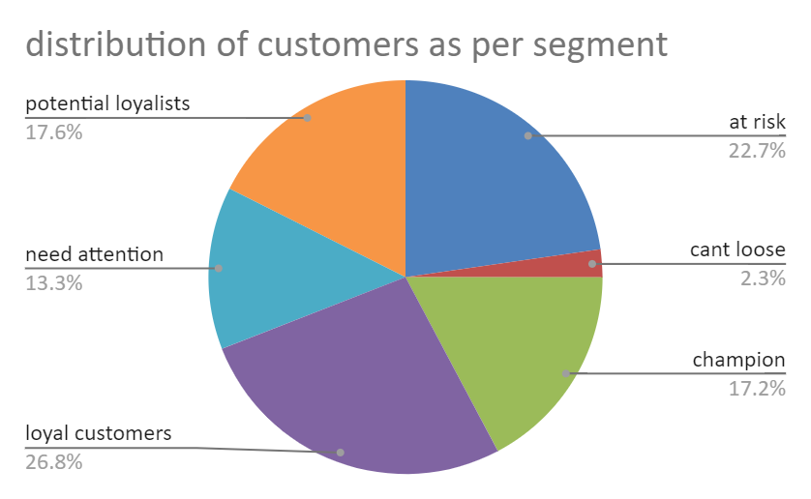

| **questions** | **segments** | **number of customers** |
| --- | --- | --- |
| Which of your customers could contribute to your churn rate? | hibernating,at risk | 569 |
| Which of your customers are most likely to respond to engagement campaigns? | new customer, champian,potential loyalists,promising | 431 |
| Who are your best customers? | champion | 431 |
| Which of your customers can be retained? | need attention,loyal customers | 1006 |
| Who has the potential to become valuable customers? | potential loyalists | 440 |

| **Top 3 country which are best for the company?** |  |
| --- | --- |
|  |  |
| *country* | COUNT of CustomerID |
| United Kingdom | 97 |
| India | 89 |
| Australia | 87 |
| USA | 84 |
| China | 74 |
|  |  |

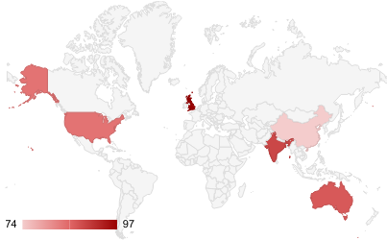

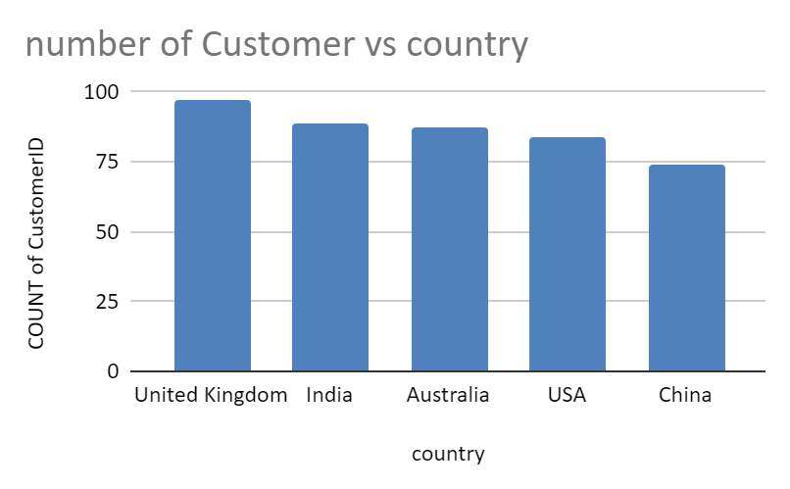

**Customers whose monetary value is more than 700 and best in united kingdom**

| *CustomerID* | SUM of Monetary value |
| --- | --- |
| 17,511 | 3733.74 |
| 16,839 | 863.52 |
| 15,039 | 854.31 |
| 14,292 | 785.2 |
| 15,856 | 757.54 |

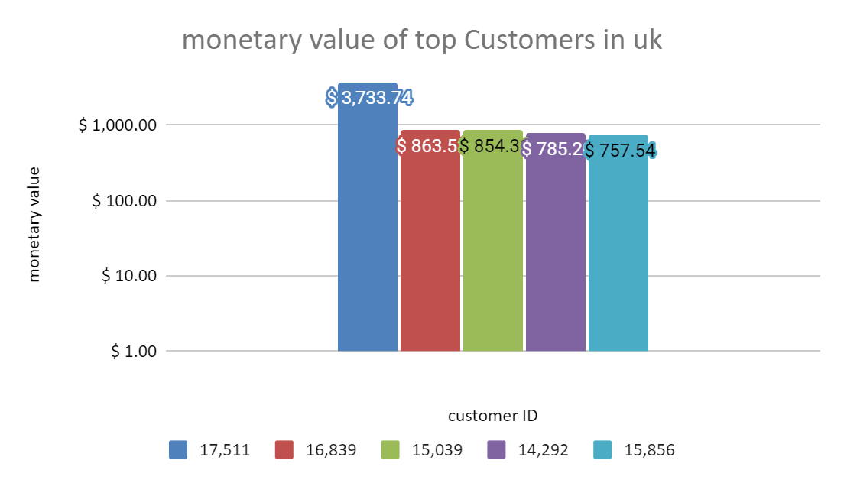

**Top 3 sold item (stock code)**

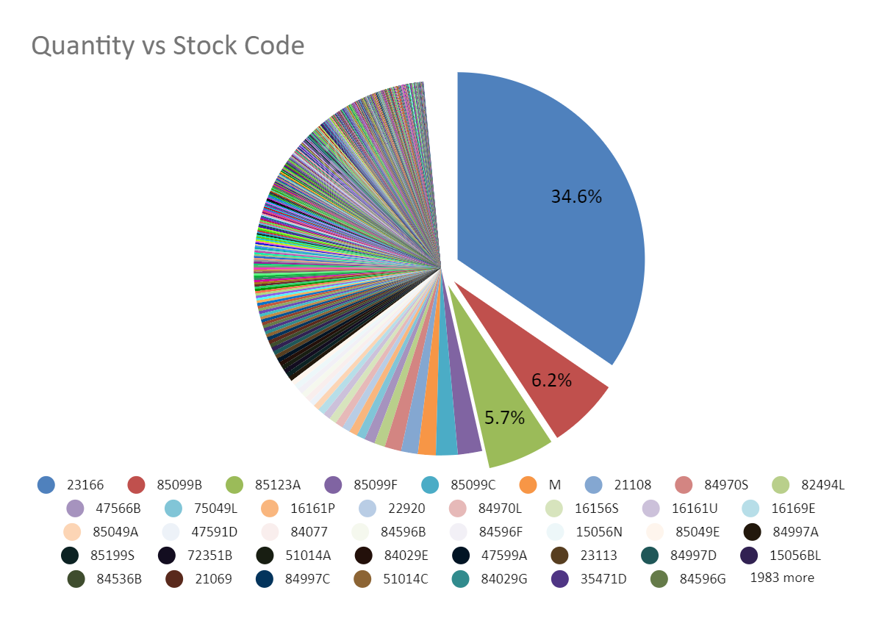

| **items whose monetary value is more than 7000 in united kingdom** |  |
| --- | --- |
|  |  |
| *SUM of Monetary Value* | *country* |
| *StockCode* | United Kingdom |
| M | 43503.1 |
| 85123A | 1275 |
| 84078A | 838.8 |
| 22920 | 833.25 |

